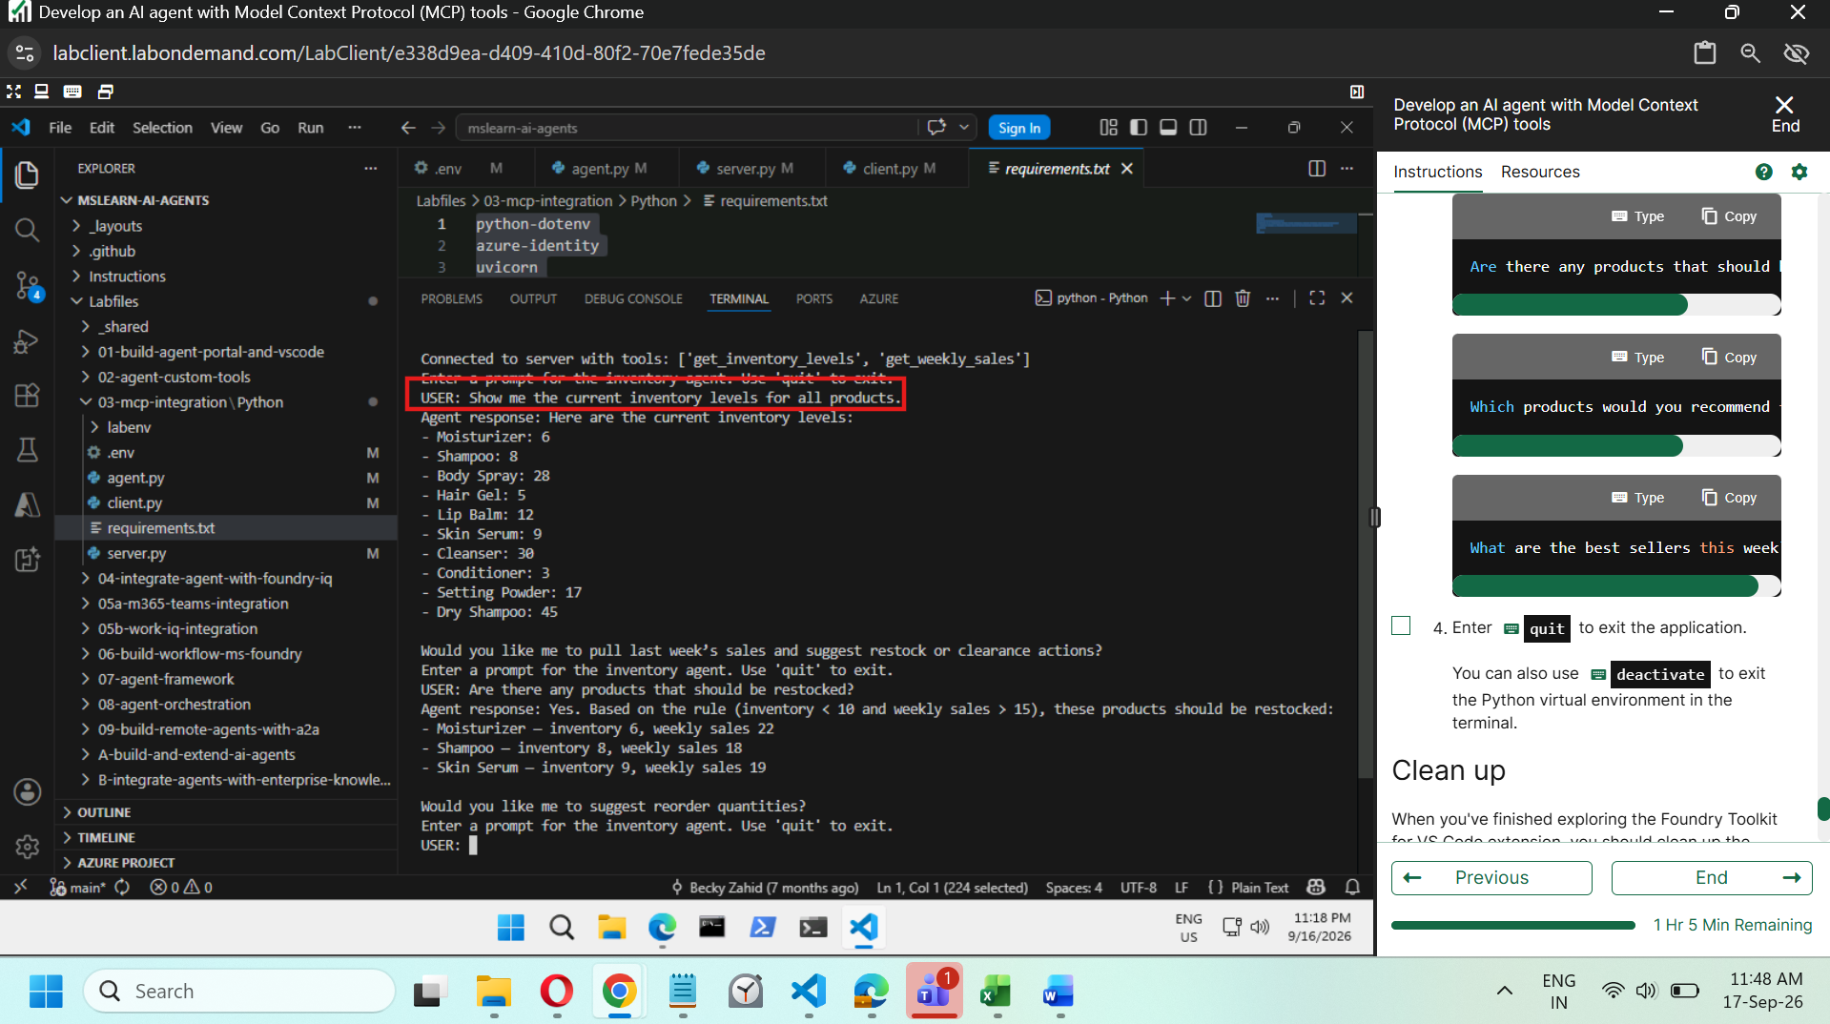
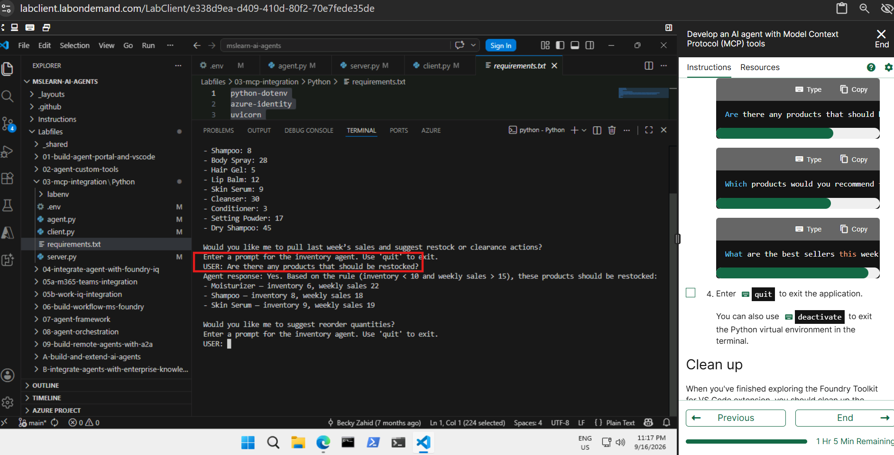

Agent.py :

import os
from dotenv import load_dotenv

# Add references
# Add references
from azure.identity import DefaultAzureCredential
from azure.ai.projects import AIProjectClient
from azure.ai.projects.models import PromptAgentDefinition, MCPTool
from openai.types.responses.response_input_param import McpApprovalResponse, ResponseInputParam

# Load environment variables from .env file
load_dotenv()
project_endpoint = os.getenv("PROJECT_ENDPOINT")
model_deployment = os.getenv("MODEL_DEPLOYMENT_NAME")

# Connect to the agents client
# Connect to the agents client
with (
DefaultAzureCredential() as credential,
AIProjectClient(endpoint=project_endpoint, credential=credential) as project_client,
project_client.get_openai_client() as openai_client,
):

# Initialize agent MCP tool
# Initialize agent MCP tool
mcp_tool = MCPTool(
server_label="api-specs",
server_url="https://learn.microsoft.com/api/mcp",
require_approval="always",
)

# Create a new agent with the MCP tool
# Create a new agent with the MCP tool
agent = project_client.agents.create_version(
agent_name="MyAgent",
definition=PromptAgentDefinition(
model=model_deployment,
instructions="You are a helpful agent that can use MCP tools to assist users. Use the available MCP tools to answer questions and perform tasks.",
tools=[mcp_tool],
),
)
print(f"Agent created (id: {agent.id}, name: {agent.name}, version: {agent.version})")

# Create conversation thread
# Create a conversation thread
conversation = openai_client.conversations.create()
print(f"Created conversation (id: {conversation.id})")

# Send initial request that will trigger the MCP tool
# Send initial request that will trigger the MCP tool
response = openai_client.responses.create(
conversation=conversation.id,
input="Give me the Azure CLI commands to create an Azure Container App with a managed identity.",
extra_body={"agent_reference": {"name": agent.name, "type": "agent_reference"}},
)

# Process any MCP approval requests that were generated
# Process any MCP approval requests that were generated
# The agent may issue several tool calls, each needing its own approval,
# so we loop until there are none left.
while True:
# Collect any MCP approval requests from the latest response
input_list: ResponseInputParam = []
for item in response.output:
if item.type == "mcp_approval_request":
if item.server_label == "api-specs" and item.id:
# Automatically approve the MCP request to allow the agent to proceed
input_list.append(
McpApprovalResponse(
type="mcp_approval_response",
approve=True,
approval_request_id=item.id,
)
)

# No more approvals needed -> the agent has produced its final response
if not input_list:
break

# Send the approval response back and retrieve the next response
response = openai_client.responses.create(
input=input_list,
previous_response_id=response.id,
extra_body={"agent_reference": {"name": agent.name, "type": "agent_reference"}},
)

print(f"\nAgent response: {response.output_text}")

# Clean up resources by deleting the agent version
# Clean up resources by deleting the agent version
project_client.agents.delete_version(agent_name=agent.name, agent_version=agent.version)
print("Agent deleted")

client .py
import os
import asyncio
import json
from dotenv import load_dotenv
from contextlib import AsyncExitStack
from azure.ai.projects import AIProjectClient
from azure.ai.projects.models import FunctionTool
from azure.identity import DefaultAzureCredential
from azure.ai.projects.models import PromptAgentDefinition, FunctionTool
from openai.types.responses.response_input_param import FunctionCallOutput, ResponseInputParam

# Add references
# Add references
from mcp import ClientSession, StdioServerParameters
from mcp.client.stdio import stdio_client

# Clear the console
os.system('cls' if os.name=='nt' else 'clear')

# Load environment variables from .env file
load_dotenv()
project_endpoint = os.getenv("PROJECT_ENDPOINT")
model_deployment = os.getenv("MODEL_DEPLOYMENT_NAME")

async def connect_to_server(exit_stack: AsyncExitStack):
server_params = StdioServerParameters(
command="python",
args=["server.py"],
env=None
)

# Start the MCP server
# Start the MCP server
stdio_transport = await exit_stack.enter_async_context(stdio_client(server_params))
stdio, write = stdio_transport

# Create an MCP client session
# Create an MCP client session
session = await exit_stack.enter_async_context(ClientSession(stdio, write))
await session.initialize()

# List available tools
# List available tools
response = await session.list_tools()
tools = response.tools
print("\nConnected to server with tools:", [tool.name for tool in tools])

return session

async def chat_loop(session):

# Connect to the agents client
with (
DefaultAzureCredential() as credential,
AIProjectClient(endpoint=project_endpoint, credential=credential) as project_client,
project_client.get_openai_client() as openai_client,
):

# Get the mcp tools available from the server
response = await session.list_tools()
tools = response.tools

# Build a function for each tool
# Build a function for each tool
def make_tool_func(tool_name):
async def tool_func(**kwargs):
result = await session.call_tool(tool_name, kwargs)
return result

tool_func.__name__ = tool_name
return tool_func

# Store the functions in a dictionary for easy access when processing function calls
functions_dict = {tool.name: make_tool_func(tool.name) for tool in tools}

# Create FunctionTool definitions for the agent
# Create FunctionTool definitions for the agent
mcp_function_tools: FunctionTool = []
for tool in tools:
function_tool = FunctionTool(
name=tool.name,
description=tool.description,
parameters={
"type": "object",
"properties": {},
"additionalProperties": False,
},
strict=True
)
mcp_function_tools.append(function_tool)

# Create the agent
# Create the agent
agent = project_client.agents.create_version(
agent_name="inventory-agent",
definition=PromptAgentDefinition(
model=model_deployment,
instructions="""
You are an inventory assistant. Here are some general guidelines:
- Recommend restock if item inventory < 10 and weekly sales > 15
- Recommend clearance if item inventory > 20 and weekly sales < 5
""",
tools=mcp_function_tools
),
)

# Create a thread for the chat session
conversation = openai_client.conversations.create()

# Create an input list to hold function call outputs to send back to the model
input_list: ResponseInputParam = []

while True:
user_input = input("Enter a prompt for the inventory agent. Use 'quit' to exit.\nUSER: ").strip()
if user_input.lower() == "quit":
print("Exiting chat.")
break

# Send a prompt to the agent
openai_client.conversations.items.create(
conversation_id=conversation.id,
items=[{"type": "message", "role": "user", "content": user_input}],
)

# Retrieve the agent's response, which may include function calls to the MCP server tools
response = openai_client.responses.create(
conversation=conversation.id,
extra_body={"agent_reference": {"name": agent.name, "type": "agent_reference"}},
input=input_list,
)

# Check the run status for failures
if response.status == "failed":
print(f"Response failed: {response.error}")

# Process function calls
# Process function calls
for item in response.output:
if item.type == "function_call":
# Retrieve the matching function tool
function_name = item.name
kwargs = json.loads(item.arguments)
required_function = functions_dict.get(function_name)

# Invoke the function
output = await required_function(**kwargs)

# Append the output text
input_list.append(
FunctionCallOutput(
type="function_call_output",
call_id=item.call_id,
output=output.content[0].text,
)
)

# Send function call outputs back to the model and retrieve a response
# Send function call outputs back to the model and retrieve a response
if input_list:
response = openai_client.responses.create(
input=input_list,
previous_response_id=response.id,
extra_body={"agent_reference": {"name": agent.name, "type": "agent_reference"}},
)
print(f"Agent response: {response.output_text}")

# Delete the agent when done
print("Cleaning up agents:")
project_client.agents.delete_version(agent_name=agent.name, agent_version=agent.version)
print("Deleted inventory agent.")

async def main():
import sys
exit_stack = AsyncExitStack()
try:
session = await connect_to_server(exit_stack)
await chat_loop(session)
finally:
await exit_stack.aclose()

if __name__ == "__main__":
asyncio.run(main())

server.py
# Add references
# Add references
from fastmcp import FastMCP

# Create an MCP server
# Create an MCP server
mcp = FastMCP(name="Inventory")

# Add an inventory check mcp tool
@mcp.tool()
def get_inventory_levels() -> dict:
"""Returns current inventory for all products."""
return {
"Moisturizer": 6,
"Shampoo": 8,
"Body Spray": 28,
"Hair Gel": 5,
"Lip Balm": 12,
"Skin Serum": 9,
"Cleanser": 30,
"Conditioner": 3,
"Setting Powder": 17,
"Dry Shampoo": 45
}

# Add a weekly sales mcp tool
@mcp.tool()
def get_weekly_sales() -> dict:
"""Returns number of units sold last week."""
return {
"Moisturizer": 22,
"Shampoo": 18,
"Body Spray": 3,
"Hair Gel": 2,
"Lip Balm": 14,
"Skin Serum": 19,
"Cleanser": 4,
"Conditioner": 1,
"Setting Powder": 13,
"Dry Shampoo": 17
}

# Run the MCP server
# Run the MCP server
mcp.run(show_banner=False)

